Honors Biology
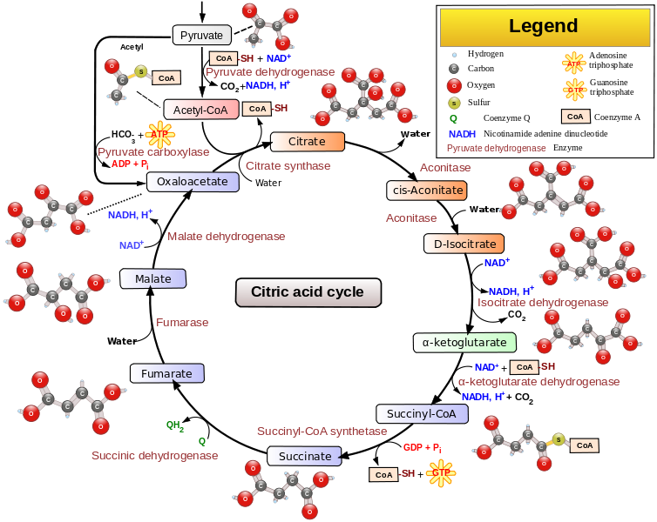
Step-by-Step Krebs Cycle
Directions: You will write a step by step guide to the Krebs Cycle based on the diagram below.
FAD⁺ + 2 H + 2 e⁻
FADH₂
ADP + P
ATP

