Honors Biology Name:
Franklin and Wilkins’ Investigation: Taking a picture of DNA
What year did wilkins’ and Franklin’s investigation occur?

Who took the first picture of DNA?

Diagram how x-ray diffraction crystallography works.

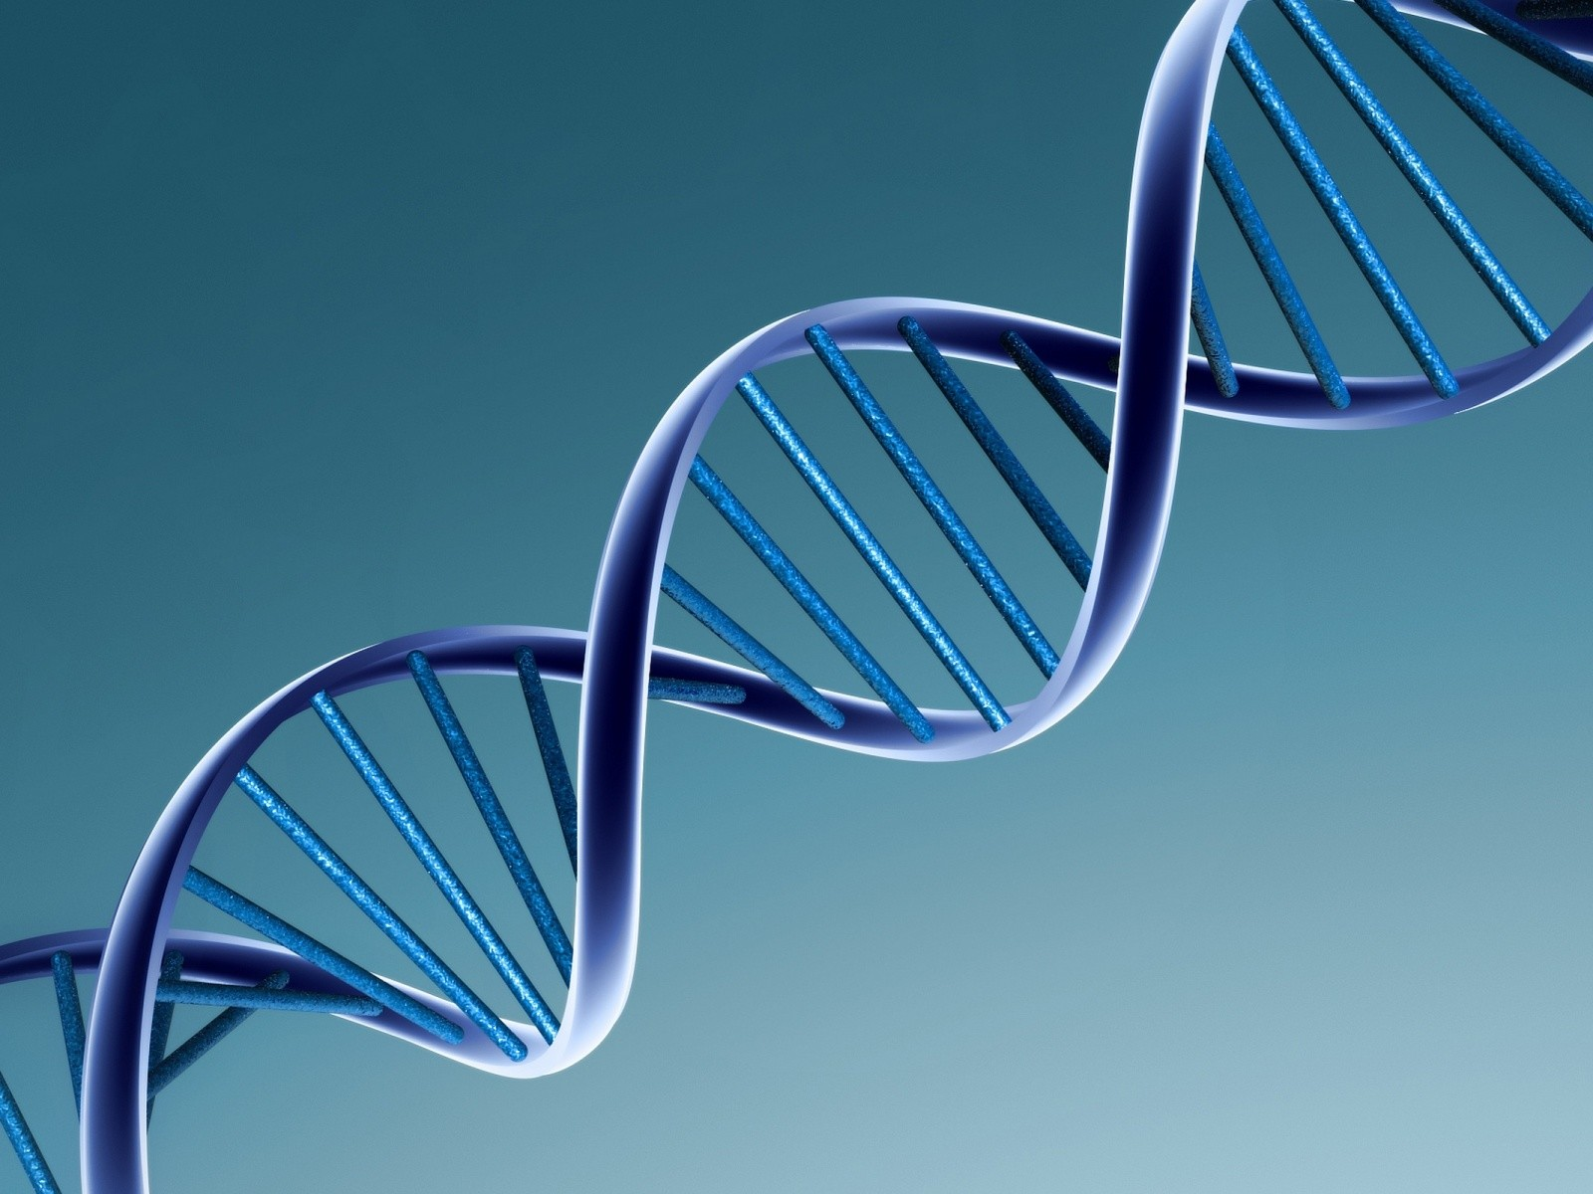
Why didn’t Franklin win the Nobel prize? Do you agree with that decision?
Recreate photo 51 and label the parts of the photo.
Who figured out what Franklin’s photo 51 showed? Why?
Discuss what Franklin was able to accomplish that Wilkins was not able to.
Why didn’t Wilkins and Franklin get along?
Make an analogy of how x-ray diffraction crystallography works

