Environmental Systems and Societies
Closed Ecosystem Study Part 1

How it works:
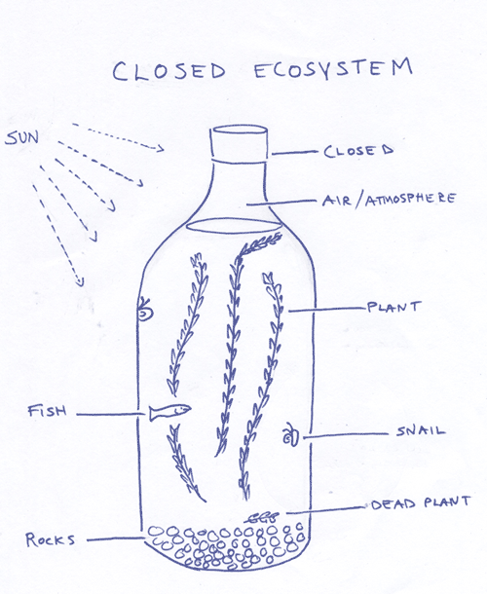
- The Glass jar: transmits light, but prevents matter from entering or leaving.
- Photosynthesiszer (floating plant): converts light and CO₂ to O₂ and food for animals.
- Recyclers: Microbes include photosynthetic algae and decomposing bacteria which variously consume or liberate chemical nutrients.
- Cleaning crew: Assorted snails consume algae. Clean the glass walls, and reproduce freely.
- Refuge: Ornament provides hiding place for small or stressed animals.
- pH buffer: Rocks, shells or mineral powders contain CaCO₃ which helps stabilize the pH.
- Econaut: A shrimp or fish that consumes algae and plant matter like all animals, it consumes O₂ and emits CO₂.
- Energy Source: Light from sun or bulb powers photosynthesis.
- Scavengers: Tiny amphipods, ostracods, and/or copepods such as Cyclops eat tiny bits of plant and animal matter.

How to build the ecosystem:
1. Rinse your jar, ornaments, rocks, etc. with (nitrate –poor fresh water) NPFW. This is tap water dechlorinated and supplemented with freshwater mineral mix.
2. Fill your jar halfway with NPFW and add the ingredients

